Laptop Request Catalog Item

Team ID : NM2025TMID15987

Team Size : 4

Team Leader : M. GURUPRASHATH

Team member : THAUFIQ UMAR .K

Team member : VIGNESH .B

Team member : IMMANUEL JEBARAJ .C

# Task Initiation:

Step 1: Create Local Update Set

1.Open service now.

2.Click on All >> search for update sets

3.Select local update sets under system update sets

4.Click on new

5.Fill the following details to create a update set as: “Laptop Request”

6.Click on submit and make current

7.By clicking on the button it activates the update set .

Step 2: Create Service Catalog Items

1.Open service now.

2.Click on All >> service catalog

3.Select maintain items under catalog definitions

4.Click on New.

5.Fill the following details to create a new catalog item

Name: Laptop Request

Catalog: service Catalog

Category: Hardware

Short Description: Use this item to request a new laptop

6.Click on ‘SAVE’

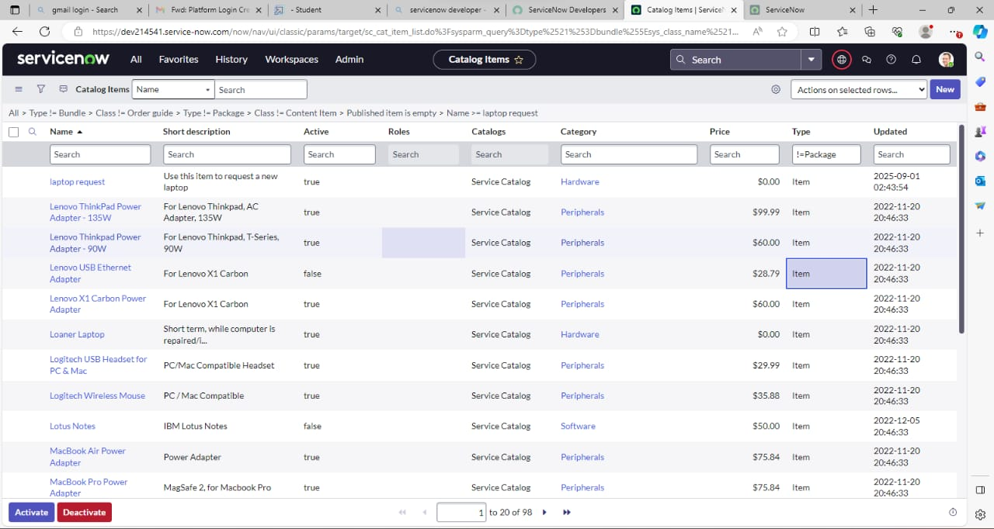

Step 3: Create Catalog UI Policies

1.Click on all>> search for service catalog

2.Select maintain item under catalog definition

3.Search for ‘laptop request’ which is created before

4.Select ‘laptop request’ and scroll down click on “Catalog Ui policies”

5.In the catalog ui policies related list tab click on new

6.Give short description as: show accessories details

7.Set the Catalog Condition in the related list tab ‘when to apply’

                  [field: additional_ accessories, operator: is, value: true]

1. Click on **save**.(do not click on submit)
2. Scroll down and select ‘catalog ui action’
3. Then click on new button
4. Select variable name as: accessories_details

                              Order:100

                    Mandatory: True

                         Visible : True

1. Click on save and again click save button of the catalog ui policy form

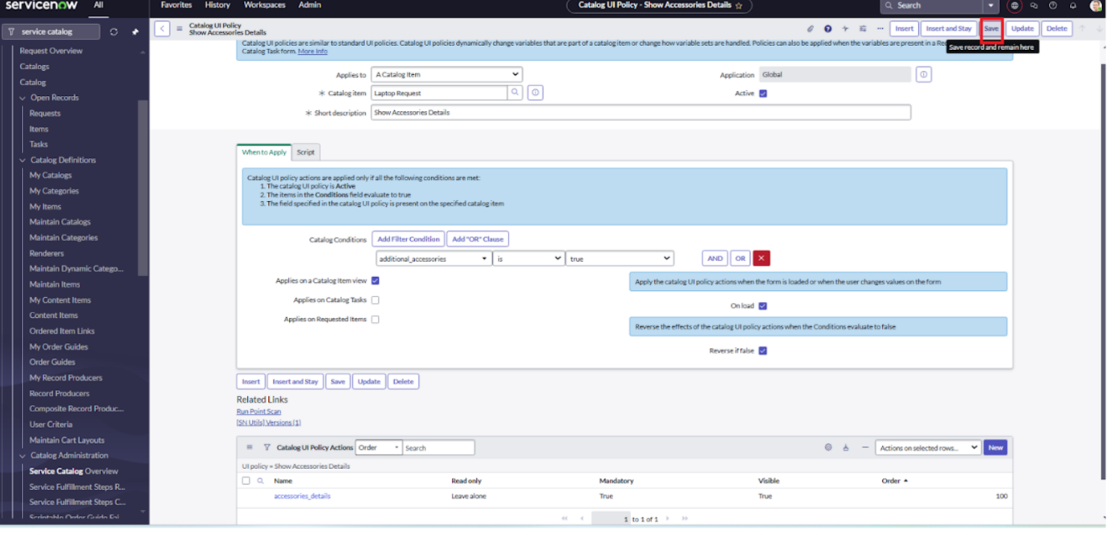

Step 4: Create UI Actions

1.Open service now.

2.Click on All  >> search for ui action

3.Select ui actions under system definition

4.Click on new

5.Fill the following details to create ui action

              Table: shopping cart(sc_cart)  
              Order:100  
              Action name:  Reset form  
               Client : checked  
6.Script:  
    function resetForm() {  
    g_form.clearForm(); // Clears all fields in the form  
    alert("The form has been reset.");  
}  
  
7.Click on save

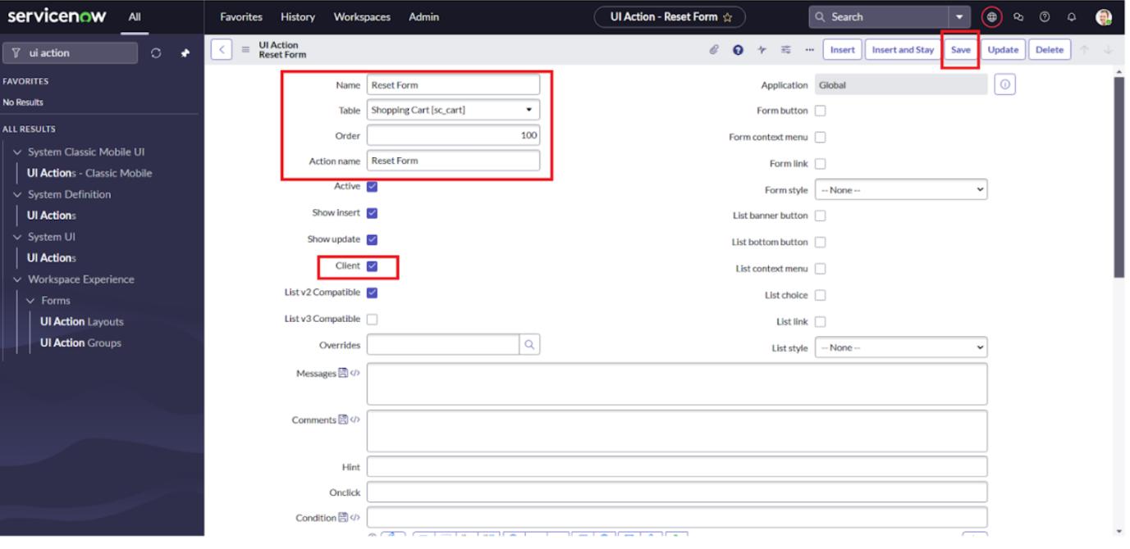

Step 5: Export Update Set

1.Click on All  >> search for update sets

2.Select local update set

3.Select created update set i.e. ‘Laptop Request Project’

4.Set the state to ‘Complete’

5.In the related list Update tab, updates are visible which we perform under this update set.

6.Click on export to XML ,it download one file

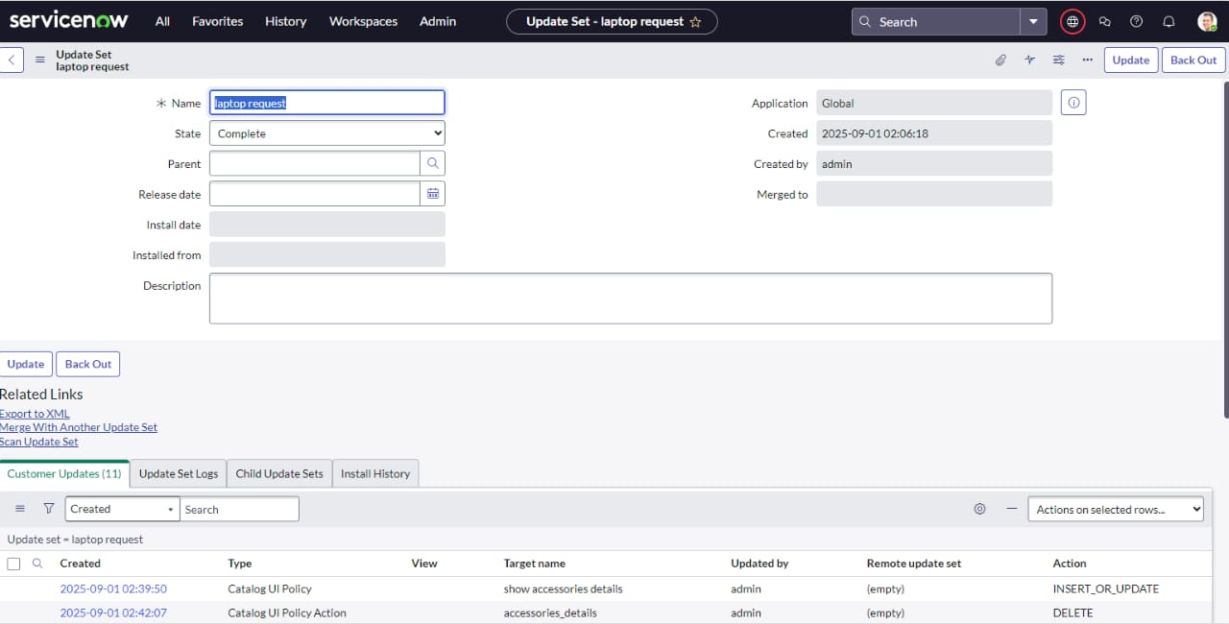

Step 6: Retrieving The Update Set

1.Open another instance in incognito window

2.Login with credentials

3.Click on all>> search for update sets

4.Select “Retrieved update set” under system update set

5.It open retrieved update set list and scroll down

6.Click on Import update set from XML

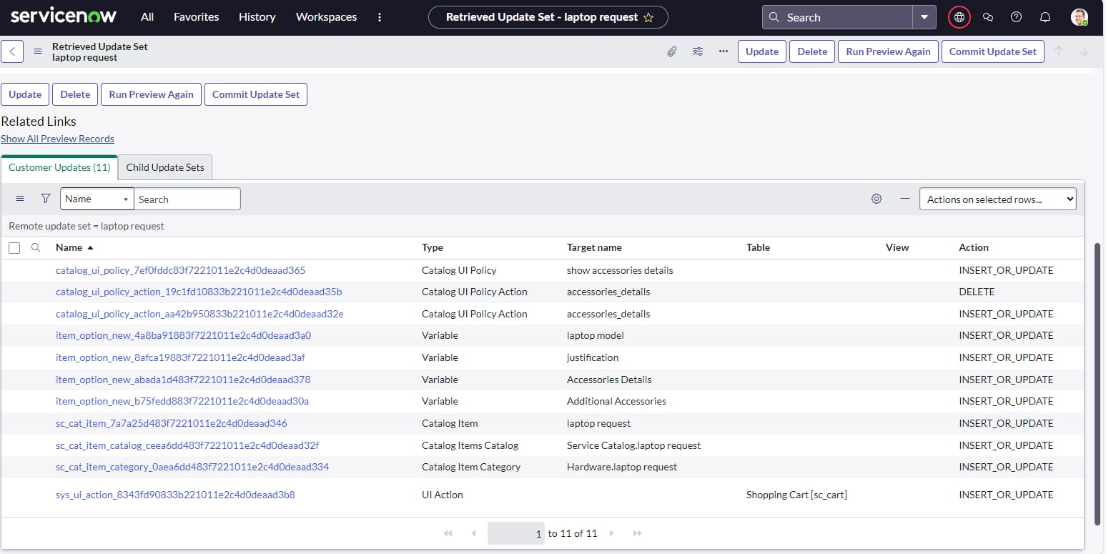

Step 7: Test Catalog Item

1.Search for service catalog in application navigator in target instance

2.Select catalog under service catalog

3.Select  hardware category and search for ‘laptop request’ item

4.Select laptop request item and open  it

5.It shows three variables only

6.As per our scenario, when we click on additional accessories checkbox then accessories details fields is visible and that should be mandatory

7.Now  see the results,it fulfills our requirements.

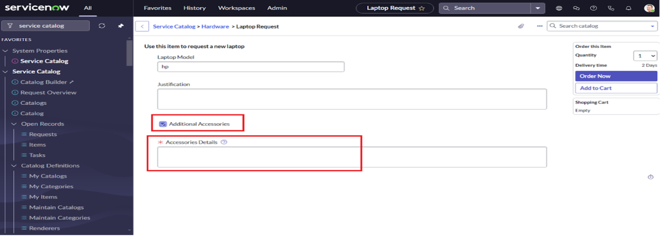

Conclusion:

 The Laptop Request Catalog Item project successfully streamlines the process of requesting laptops within the organization by leveraging ServiceNow's Service Catalog capabilities. Through the implementation of a dynamic catalog item, the project ensures that users have an intuitive and user-friendly interface, reducing errors and improving efficiency.This project demonstrates how ServiceNow can be used to replace manual, error-prone processes with automated, efficient, and user-centric solutions. It not only improves service delivery but also enhances employee satisfaction by providing a modern and streamlined request experience.